
DEPARTMENT OF

COMPUTER

SCIENCE &

ENGINEERING

Experiment 6
Student Name: Avin Mehla UID: 23BAI70080
Branch: BE CSE AIML Section/Group: 23AIT-KRG G1
Semester: 6th Date of Performance: 7 March 2026
Subject Name: Full Stack Subject Code: 23CSH-382

- Title:
Spring Boot REST API – HealthHub

- Aim:
To design and implement a Spring Boot REST API using Layered
Architecture, applying Inversion of Control (IoC) and Dependency Injection
(DI) to build a structured backend for the HealthHub application, including CRUD operations, DTO mapping, validation, and global exception handling.

- Objective:
After completing this experiment, students will be able to:
1. Understand Spring Boot fundamentals
      - Learn the role of Spring Boot in backend development.
      - Configure and run a basic Spring Boot application.
2. Apply IoC and Dependency Injection
      - Understand how Spring manages object creation and dependencies.
      - Use annotations like @Autowired, @Service, and @Repository.
3. Implement Layered Architecture
      - Structure the application using Controller, Service, and Repository layers.
      - Understand separation of concerns in backend design.
- Develop RESTful APIs
    - Create CRUD operations using Spring Boot REST controllers.
    - Design APIs using proper HTTP methods (GET, POST, PUT, DELETE).
- Use DTOs for API communication
• Implement DTO mapping to separate internal models from API responses.
- Implement Validation
• Apply validation using Jakarta Validation annotations (@NotNull, @Email, etc.).
- Handle Exceptions Globally
• Implement global exception handling using @ControllerAdvice.
- Build the HealthHub Backend Module
• Develop backend services for patient/health record management.

- Implementation/Code:
  - Patient.java:
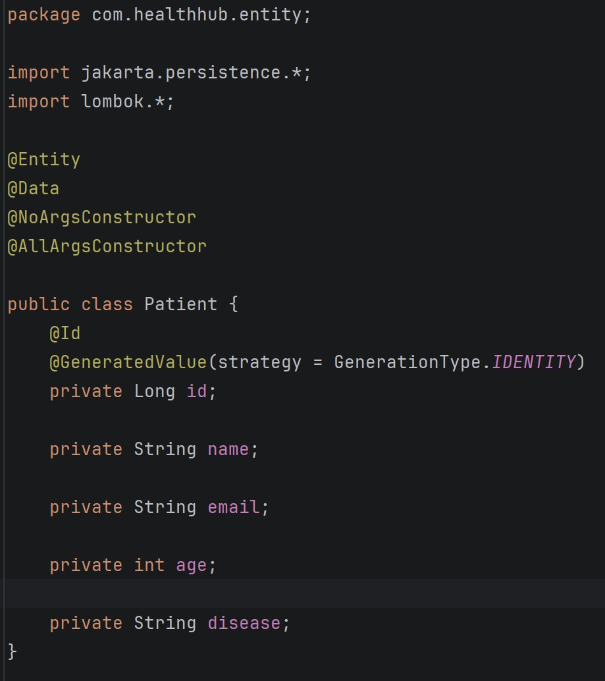
  - PatientDTO.java:
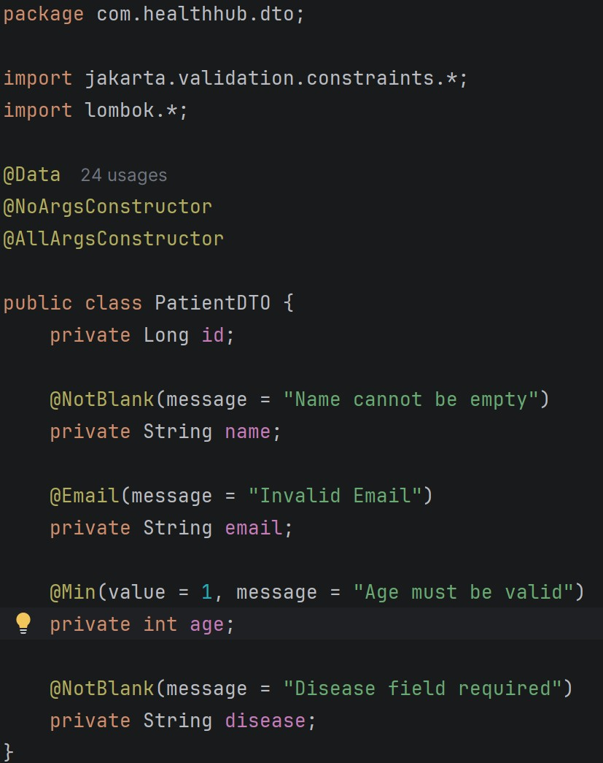

  - PatientRepo.java:
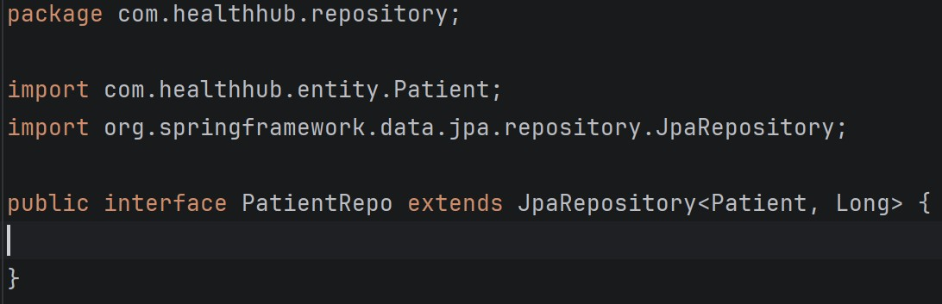

  - PatientController.java:
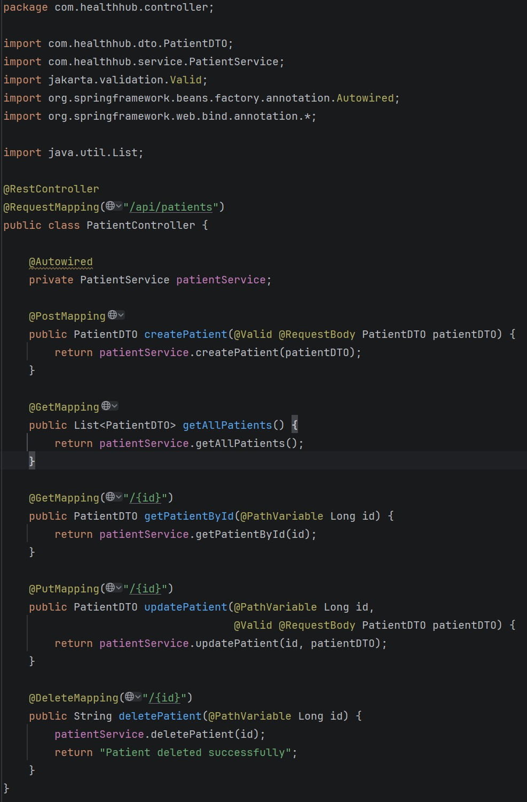

  - PatientService.java:

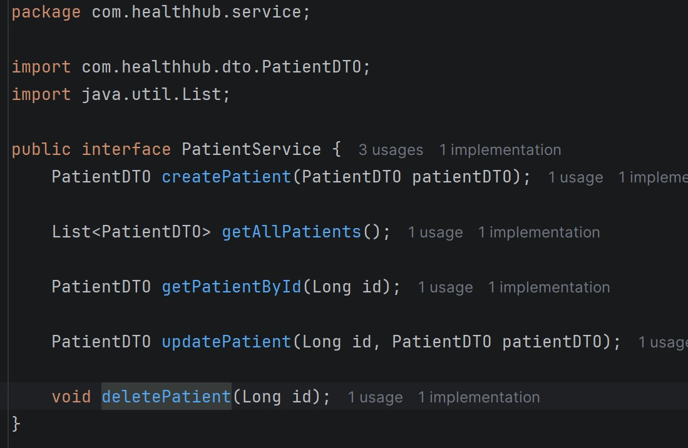
  - PateintServiceImpl.java:
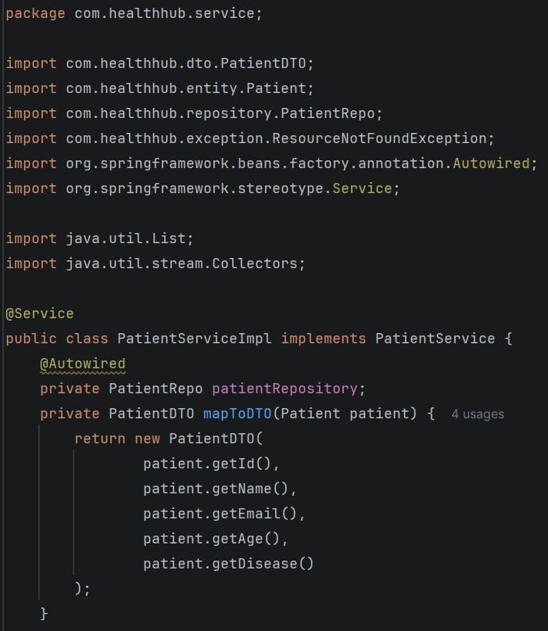
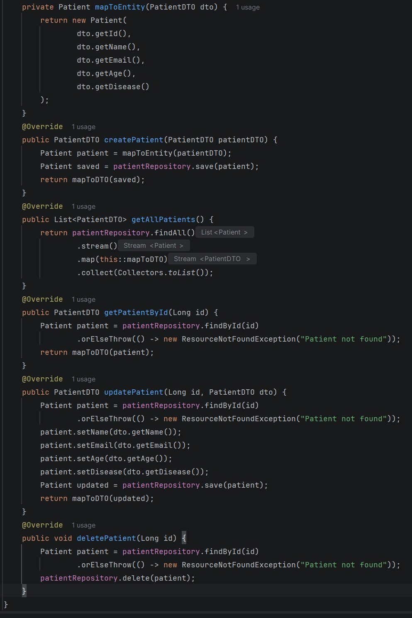
  - GlobalExceptionHandler.java:
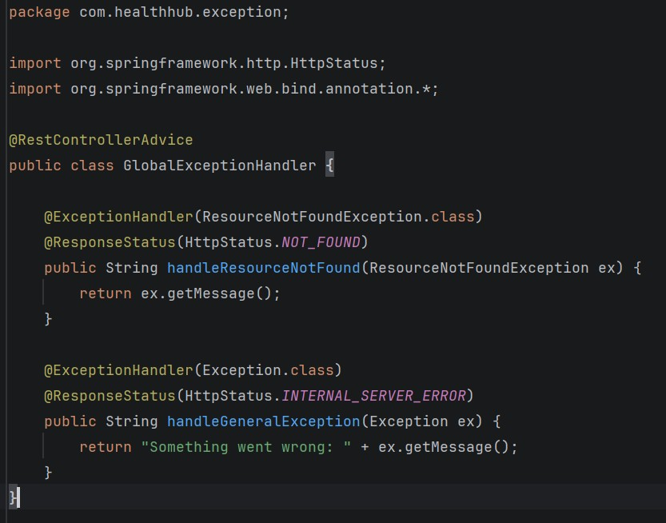
  - ResourceNotFoundException.java:
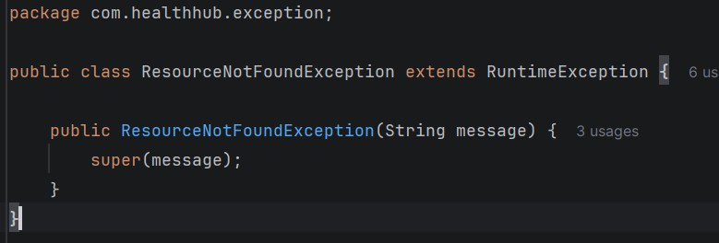

  - HealthHubApplication,http:
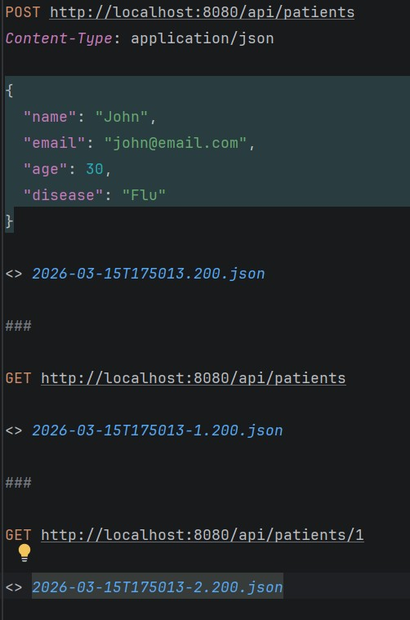
- Output

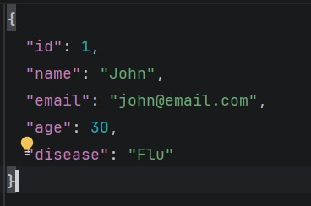
Fig1. Post Request
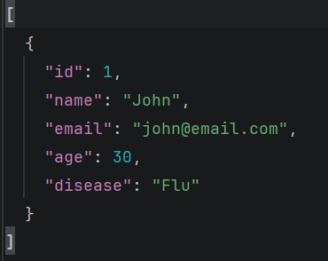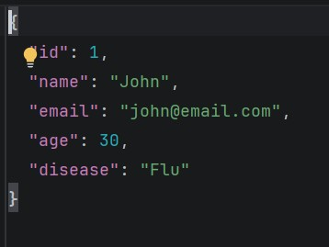
Fig 2. Get requests (2.1: GET Patients; 2.2: GET patients/1)
- Learning Outcome
    - We learnt about Spring.
    - We learnt about Spring Architecture.
    - We learnt about GET, POST and PUT requests.
    - We learnt about Exception handling in Spring.
    - We learnt about various Spring dependencies.

